OFFICIAL MEET ANNOUNCEMENT
DATES July 14-17, 2010
MEET MANAGERS: Beth Evans Lynda Warner
9971 Elmada Lane lrwarner@verizon.net
Dallas, TX 75220 817-846-7996
214-448-7937
bethevansdallas@aol.com
FACILITY: North Lake College Natatorium
5001 N. MacArthur Blvd
Irving, TX 75038
POOL SPECS: Outdoor pool is 25 yards by 65 feet (8 lanes)
Depth is 14 feet at entry, sloping to 7 feet at the bulkhead
Distance of water from deck level: 0 inches
Lap warm-up pool available throughout the meet
No entry obstructions
Judges will be in two elevated clusters on both sides of the pool
POOL RENTAL: Pool rental is available on Tuesday, July 13th at the rate of $125 per hour and will be reserved in one hour increments. Interested parties should contact Lynn Harper at lharper@dcccd.edu. Checks should be made payable to the City of Irving and be presented 15 minutes before scheduled reservation time.
RULES TO GOVERN: The 2010 Official USA Synchro Rulebook shall govern the Championships under FINA
Rules with the exceptions listed.
ENTRIES Appendix A, B, C, D, G: Register online at www.usasynchro.org for Entries, Entry Fee Summary, Host Fee Summary, Purchase of Extra Credentials, Music Selection
Appendix F: Register online at www.usasynchro.org for Officials Availability
Form E: Mail to meet manager for Transportation and Housing Information
Form H: Foreign Federation Entry must be completed by all foreign entries. Foreign competitors may enter only with written approval of their own Federations. This approval must be submitted to USA Synchro before visa assistance can be provided and before the final entry deadline.
ENTRY DEADLINE Entries and forms must be submitted electronically and postmarked by Wednesday, June 23, 2010.
If a qualifying event is held after the entry deadline for this competition, a provisional entry must be submitted according to the above deadline. Within 72 hours of the completion of the qualifying competition, the proof of qualification must be submitted by phone and in writing to the Meet Manager.
Meet qualification will be entered in on line registration, showing qualifying meet, year, and qualifying score.
Entry is not complete unless fees accompany entry, including Foreign Federations.
SEND FORM E TO: Beth Evans
9971 Elmada Lane
Dallas, TX 75220
bethevansdallas@aol.com
SEND FORM H TO: Jennifer Hawkins
USA Synchro
132 E. Washington Street, Suite 820
Indianapolis, IN 46204
Phone: (317) 237-5700
Fax: (317) 237-5705
jennifer@usasynchro.org
SCORING CHAIR Candie Deatherage
3037 Robin Road
Plano, TX 75075
candie0727@gmail.com
HOST HOTEL: Fairfield Inn & Suites by Marriott – Las Colinas
630 W. John Carpenter Freeway
Irving, TX 75039
972-550-8800
Reservations blocked under: “PTX Synchro”
Room rate: $65
Fairfield Inn & Suites Dallas Las Colinas
The hotel offers a free deluxe continental breakfast, free transportation to local restaurants, free high-speed internet, complimentary parking and complimentary coffee/tea available all day. Many restaurants may be found within 4 miles of the hotel.
Note: Foreign Federations should contact Virginia Minor at the hotel directly if requesting help with transportation. Phone: 972-510-1221 Email: Virginia@dallasmc.com
AIRPORT: Dallas/Fort Worth International (DFW) - 8 miles (15 minutes to Irving)
Dallas, Love Field (DAL) - 12 miles (20 minutes to Irving)
To help our members, we have an agreement with United Airlines. To receive a discount off the lowest available fare, call United at 800-841-0460 and tell them you're with "U.S. Synchronized Swimming” and use code 565EG.
GROUND TRANSP: All participants are on their own for transportation. All Major Rental Car Companies are available at both airports. Note: Foreign Federations may contact the hotel for assistance with transportation.
PROGRAM: Available for sale at the meet
AWARDS: All competitors will compete for the same awards. Medals shall be awarded for places 1-3, and ribbons for places 4-12.
REGISTRATION Tuesday, July 13 5 pm - 6 pm Host Hotel (Fairfield Inn & Suites)
Additional registration at the pool throughout the meet.
JUNIOR COACHES & OFFICIALS MEETING
Tuesday, July 13 6 pm - 7 pm Host Hotel (Fairfield Inn & Suites)
SENIOR COACHES & OFFICIALS MEETING
Friday, July 16 8 am – 9 am North Lake College Natatorium

FEE INFORMATION
- Entry Fee $25 per competitor per routine, including reserves (alternates). Make check payable to USA Synchro. Any swimmer who is listed as a reserve (alternate) for a routine and who is not swimming any other routine event shall pay the entry fee. (Rulebook, Appendix C) Foreign Federations do NOT pay this fee.
- Sponsor Fee $25 per competitor. Make check payable to USA Synchro.
- Credentials Each club will receive two coach and one chaperone credential per 10 credentialed athletes. Chaperone credentials do not allow deck access. Additional credentials can be purchased for $30.00 each. Make checks payable to USA Synchro.
- Tickets Tickets can be ordered in advance. Advance Ticket prices are Adult- $8 ($10 at the door). Senior (60+)/Youth (Ages 5-10)-$4 ($5 at the door). Kids five and under free for all Final events. Tickets are good for all events on that day. USSS Life Members are admitted to the competition free of charge (Please check-in at ticket desk). Entire week passes are available: Adult- $24 ($30 at the door). Senior/Youth - $12 ($15 at the door).
- Program There is a $20 fee for each club photo sent for the Championship Program. Photos must be submitted no later than June 23, 2010. See details regarding Program.
- Parking Free parking available on campus

EVENTS Juniors will compete in Figures, Free Routine preliminaries, and Free Routine finals. Junior Open-U.S. Clubs may enter only 3 solos, 3 duets and 3 trios with minimum standard scores. U.S. Clubs may enter an unlimited number of teams.

Seniors will compete in Technical Routines and Free Routine finals. Preliminary Free routines will be waived unless dramatically more entries than normal are received.

The top 12 in each event will move to Finals. The 13th place routine in each event will serve as the preswimmer for the event.

Juniors and Seniors may compete in the Combination as a separate event. Competitors who are 13 and 14 years of age may participate in the Combination event.
Foreign Federations:
1. Federations may enter a National Team in each category: Junior (15-18), Senior, and Combination (Open).
2. Clubs from Foreign Federations may also enter in each category: Junior, Senior, and Combination (Open).
- Senior competition: Each National Team and club from Foreign Federations may enter two solos, two duets, and/or one team.
- Junior competition: Each National Team and club from Foreign Federations may enter three solos, three duets, one trio and/or one team. Only one Junior Solo or Junior Duet from each Foreign club or National Team shall advance to Finals.
- Combination: Each National Team and club from Foreign Federations may also enter the Combination event.
- An individual competitor may only enter three events, exclusive of the Combination routine.
- Competitors who are eligible to compete as Juniors may swim in the Senior category to complete a duet or team entry. Junior athletes may not swim in the same event in both Junior and Senior categories of competition.
- Qualifying scores do not apply to Foreign Federations.
- A club or National Team may enter an unlimited number of Combination routines. An individual competitor may be entered in only one Combination routine.
JUNIOR FIGURES Figures-Junior Compulsory
313 Kip, Split, Closing 180˚ 2.5
112f Ibis, Continuous Spin (720˚) 2.8
The remaining two figures will be drawn from the Junior Selection Groups by the USA Synchro VP-Competitive Operations and posted at www.usasynchro.org on Monday, July 12 at 12 noon eastern time. The information will also be emailed to all Technical members of USA Synchro.
QUALIFYING SCORES
Routine competition in Solo, Duet, Trio, Team and Combination
Qualifying Scores: Senior (15+) Junior (15-18)
Solo: 79.0 76.0
Duet: 78.0 75.0
Trio: N/A 74.0

Team: Open Open
Combination: Open Open
Qualifying scores do not apply to Foreign Federations.
OFFICIALS Please register online by the entry deadline. In addition, please email Judges Administrator Linda Loehndorf your intent to attend (loehndorf@charter.net). The dress for all events will be white tops and white bottoms.
FINA and UANA judges will be seated with U.S. judges on the event panels.
NOTE: Federations entering may submit up to two officials from the FINA and/or UANA List(s) of Synchronized Swimming Officials for the U.S. Junior Open and the U.S. Senior Open Championships. FINA and/or UANA Judges from Federations not entered in the competition may attend to practice judge.
COACHES Please register online by the entry deadline. All US coaches on deck must be 100% certified by USA Synchro. Check that you are certified on the USASynchro.org website under Education, Coaching Certification Program. If there are any concerns, please contact Kevin in the National Office, and bring any proof of certifications not shown on the web site to registration.
SCORING We expect to use new three score scoring for free routines, but single scoring for tech routines (unless new tech routine scoring method is finalized in advance).
AWARDS All competitors (US and Foreign) will compete for the same awards. Medals shall be awarded for places 1-3, and ribbons for places 4-12. In the Senior category, medals and ribbons shall be given to reserves (alternates) who swim either the Technical or Free Routine. In the Junior category, medals and ribbons shall be given to competitors who swim in finals only.
PHOTOGRAPHER The official photographer for USA Synchro is MIGZ Photography, from whom you can order photographs onsite. Cameras with detachable lenses are not allowed in the competition venue.
PHOTO/VIDEO REGULATIONS
Any photographs, videotape or other audio and/or visual recordings of the event created by a spectator may be used solely for such spectator's personal non-commercial use, and may not be broadcast, published or disseminated, or used for any commercial purposes, without the prior written consent of U.S. Synchronized Swimming.

MEDIA SERVICES To assist the USSS Media Relations Director at the event; please bring a phone/fax list of your local media outlets. You can acquire this list from a local university athletic department Sports Information Office, University Media Relations department, or your local government public relations office.
VENUE RULES For Final events, tickets or credentials are required for admittance to the venue.
No-smoking allowed in the facility.
No glass containers on deck or in locker rooms.
Use of the pool equipment is not permitted.
All athletes will abide by the facility rules and USA Synchro Athlete Code of Conduct.
Gelling and de-gelling in the designated areas only.
All equipment bags must remain in the designated areas to maintain a clean deck.
Official team banners will be hung by meet management.
Hand-made signs may not be posted.
Coolers are permitted on deck; however NO electrical appliances are permitted.
A concession stand will be open during the Championship.
Concession stand hours will be available at registration.
Pop-up tents are allowed outside the facility.
SOUND SYSTEM A Clark Synthesis sound system with a CD player will be used.
FOOD SERVICES A concession stand will be open during competition times. Subway nearby on campus.
OFFICIALS HOSPITALITY
Hospitality will be provided for all officials, and coaches.

COACHES, OFFICIALS, SPONSORS & EVENT ORGANIZERS RECEPTION
A reception for coaches, officials, sponsors and event organizers will be held. Details to follow.
PROGRAM Participating teams are invited to send solo, duet, trio and team photos for the official championship program. Cost per photo is $20. Send digital photos only.
Instructions: Photos approx. 9" x12" (size on computer screen) at 72 or 96 dpi make better quality printed images. Save photos as an uncompressed or high quality JPEG (.jpg) digital file. If prepared correctly the digital JPEG attachment should be between 400 and 700K. Send photos as an attachment to an e-mail (DO NOT send a word text document). In the e-mail subject line indicate the team name. In the body of the e-mail include the complete name of the team, club or college, city, state, names of swimmers/coaches—listed left to right / back to front. Name your attached photo file a name that describes your team photo (i.e. PTX_duet.jpg) Send one photo and caption per e-mail (i.e. 4 photos = 4 e-mail messages.). Only images in the JPEG format and at the recommended picture size can be used for printing in the program.
If you would like to place an ad or congratulatory notice in this year’s official program, you may do so by electronically submitting an ad via email to.
ADS: 1/8 page = $25.00, ¼ page = $50.00, ½ page = $85.00, Full page = $100.00 .
Written Messages: $15 per message, not to exceed twenty words.
E-MAIL Photos, Ads and Messages to: writchie@cityofirving.org
Checks for Photos, Ads and Messages should be made payable to: IAA and should be submitted with entries by June 23, 2010.

DRIVING DIRECTIONS

From DFW Airport to Pool:
Go South on International ParkwayS/TX-97 Spur S
Take the ramp toward Airfield Dr/Parking Remote South/Rental Cars
Go slight left on S Service Road/International Parkway
Take the Airfield Drive East ramp toward Parking Remote South/DFW Administration
Merge onto S Airfield Drive
Take the E 34th/Walnut Hill Lane ramp toward I-635/Airport Exit/TX-161/TX-114
Go slight Right on W Walnut Hill Lane/E 34th Street continue to follow W Walnut Hill Lane
Turn right on Brangus Drive E
Turn Right onto Hidden Ridge
Turn Right onto N. MacArthur to the Campus

From Dallas Love Field Airport to Pool:
Go Southesat on Cedar Springs road toward Aviation Pl
Turn slight right onto W. Mockingbird Lane
Turn right onto E. John W. Carpenter Frwy
Merge onto TX-183 W via the ramp on the LEFT
Keep right to take TX-114 W toward Grapevine/DFW Airport North Entry
Take the exit toward TX-348-Spur/Northwest Hwy/Hidden Ridge Drive
Stay straight to go onto W. John W Carpenter Fwy/W TX-114
Turn left onto Hidden Ridge
Turn left onto N. Mac Arthur Blvd
From DFW Airport to Host Hotel:
Go south on International Parkway S/TX-97 Spur S
Go slight left toward Return to Terminals
Go slight left onto International Parkway N/TX-97 N
Merge onto TX-114 toward Irving/Downtown Dallas
Take the exit toward Walnut Hill Lane/Hidden Ridge Drive
Stay straight to onto W. John W Carpenter Fwy/W TX-114

From Dallas Love Field Airport to Hotel:
Go southesat on Cedar Springs road toward Aviation Pl
Turn slight right onto W. Mockingbird Lane
Turn right onto E. John W. Carpenter Frwy
Merge onto TX-183 W via the ramp on the LEFT
Keep right to take TX-114 W toward Grapevine/DFW Airport North Entry
Take the exit toward Walnut Hill Ln/MacArthur Blvd
Stay straight to go onto W. John W. Carpenter Fwy/W TX-114
Take the Walnut Hill Ln ramp toward TX-114 E
Turn left onto W Walnut Hill Ln
Turn left onto Walnut Ridge Drive
Go slight right onto W John W Carpenter Fwy/W TX-114
IRVING, DALLAS AND FORT WORTH AREA ATTRACTIONS
Mustangs of Las Colinas
Movie Studios at Las Colinas
Gondola Adventures
Mandalay Canal Walk
Heritage House
Irving Arts Center
Las Colinas Flower Clock
Center for the Arts-Irving
Marble Cow Sculpture
Six Flags over Texas-Arlington
Cowboy Stadium
Billy Bob’s Texas-Fort Worth
Fort Worth Zoo
Fort Worth Water Gardens
Kimbell Art Museum-Fort Worth
Amon Carter Museum-Forth Worth
Modern Art Museum of Fort Worth
C. R. Smith Museum-Fort Worth
Fair Park-Dallas
Dallas Zoo
Dallas Museum of Art
Dallas Museum of Natural History
Thanksgiving Square-Dallas
Sixth Floor Museum-Dallas
JFK Memorial Plaza
Frontiers of Flight Museum-Dallas
Science Place-Dallas
Dallas World Aquarium
Dallas Arboretum and Botanical Gardens
Dallas Heritage Museum at Old City Park
Pioneer Park-Dallas
Fort Worth Botanical Gardens
Sundance Square-Fort Worth
Fort Worth Museum of Science and History
Stockyards National Historic District
Ripley’s ‘Believe it or Not’ Museum-Grand Prairie
Texas Rangers Baseball Team-Arlington
IRVING, DALLAS AND FORTH WORTH AREA SHOPPING
Irving Mall
Grapevine Mills Mall
Dallas Galleria
Northpark Center-Dallas
Highland Park Village-Dallas
The Shops at Willow Bend-Plano
Stonebriar Centre-Frisco
Trader’s Village-Grand Prairie
Allen Premium Outlet Mall
TENTATIVE MEET SCHEDULE
Please consult the FINAL SCHEDULE distributed at Registration for updates or adjustments

TUESDAY, JULY 13
PM 5:00 | 6:00 | Registration at Host Hotel (Fairfield Inn & Suites by Marriott – Las Colinas)
6:00 | 7:00 | Junior Coaches & Officials meeting at Host Hotel (Fairfield Inn & Suites by Marriott – Las Colinas)

WEDNESDAY, JULY 14
AM 6:15 | 6:45 | Lap swimming only
6:45 | 7:15 | Figure Warm-up
7:20 |  | Figure Competition
 |  | Junior Team Practice with Music (one time thru/order of draw) Start time will be available in the Final Meet Schedule
THURSDAY, JULY 15
AM 6:15 | 6:45 | Open Pool
6:45 |  | Junior Solo & Trio Warm-ups and Prelims
 |  | Junior Solo & Trio Finals and Awards
FRIDAY, JULY 16
AM 6:15 | 6:45 | Open Pool
6:45 |  | Junior Duet Warm-ups and Prelims
Senior Technical Routines
* note that Senior Tech Team practice with music will be held on Friday, sometime prior to competition. Consult the final schedule for exact time.
 |  | Combo practice with Music
 |  | Junior Duet Finals and Awards
 |  | Combo Prelims

SATURDAY, JULY 17
AM 6:15 | 6:30 | Open Pool
 |  | Junior Team Warm-up and Prelims
Senior Free Routine Finals and Awards
* note that Senior Free Team practice with music will be held, sometime prior to competition. Consult the final schedule for exact time.
 |  | Junior Team Finals and Awards
 |  | Free Combination Finals and Awards
Appendix A, B, C, D & G: Club Entry Form, Entry Fee & Host Fee Summary, Credentials, Music
- To register online login to your account from the homepage of the USASynchro.org website, by clicking on “Members Log-In”.
- Login to your account. 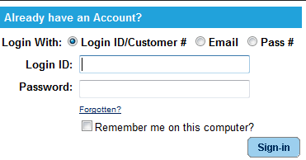
- Click on “Register for Events” under the “Other Services” section.
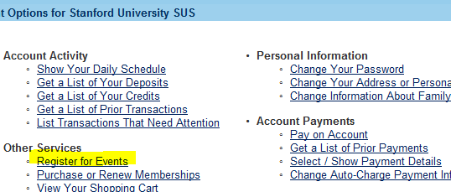
- Click on the link for the 2010 U.S. Open.
(Hint: You can find the event you are looking for quicker by filtering for the location.) 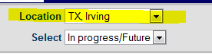
- Click on the event for which you are registering.
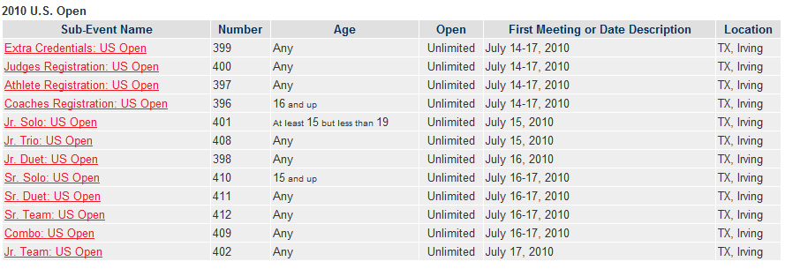
  - To Register for an individual event such as a solo, coach or athlete registration:
    - Click “Add to My Cart”
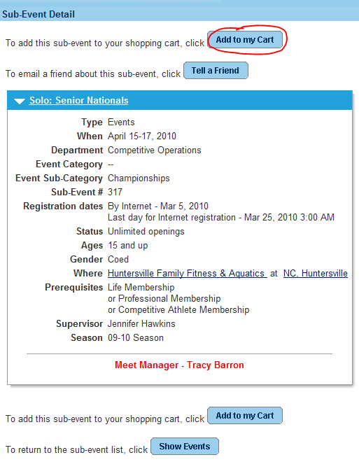
    - Use the drop-down arrow to choose the athlete (participant) entering the event.
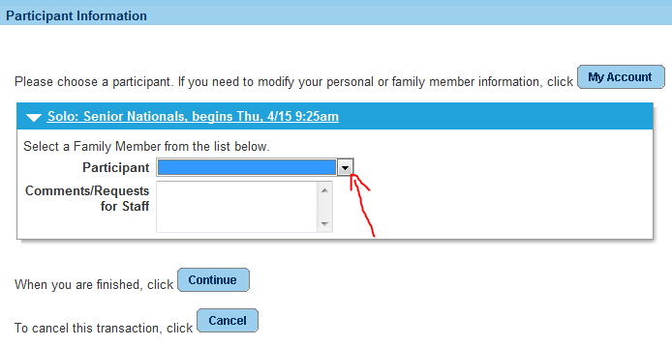
    - Answer questions and fill out music selection information. A payment option is available for clubs that need to pay by check. (It’s also highly recommended for provisional entries.) If you are choosing to mail in a check; you will need to choose the payment plan on every athlete; every event that you enroll, for the system to defer all charges. If you miss even one, you will be asked to pay by credit card upon check out.
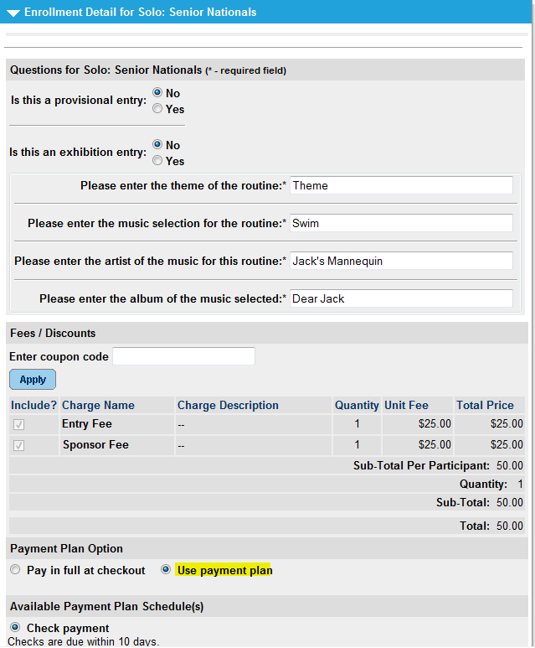
    - Click continue and your shopping cart will reflect a summary of your transaction.
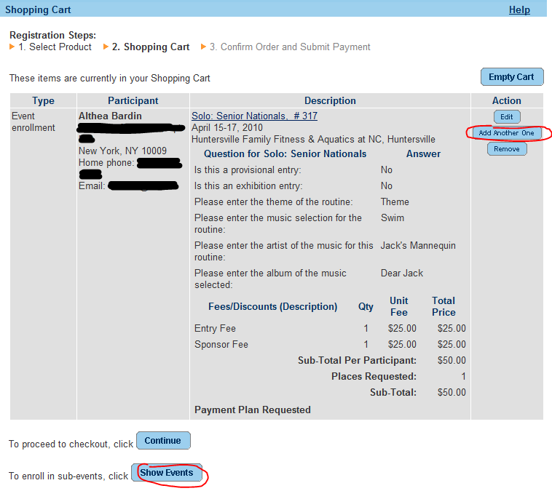
    - If you need to add another athlete to the same event, click “Add Another One”. If you are ready to choose a new event, click “Show Events”.
  - To register for group events (Team, Combo, Trio, Duet):
    - Click “Add to My Cart”
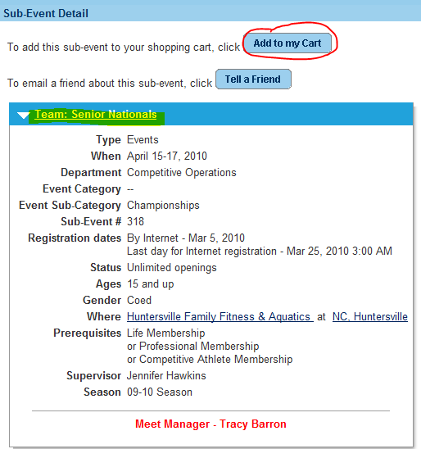
    - Use the drop-down arrow to choose the athlete (participant) entering the event and click “Continue”.
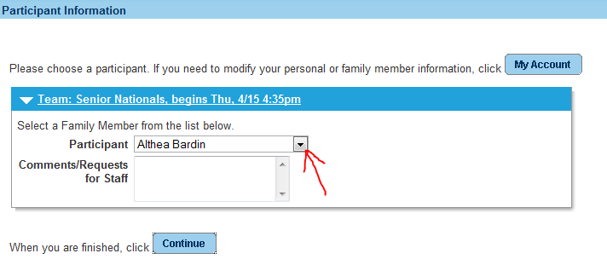
    - Click “Add Team” (This is EXTREMELY important!)
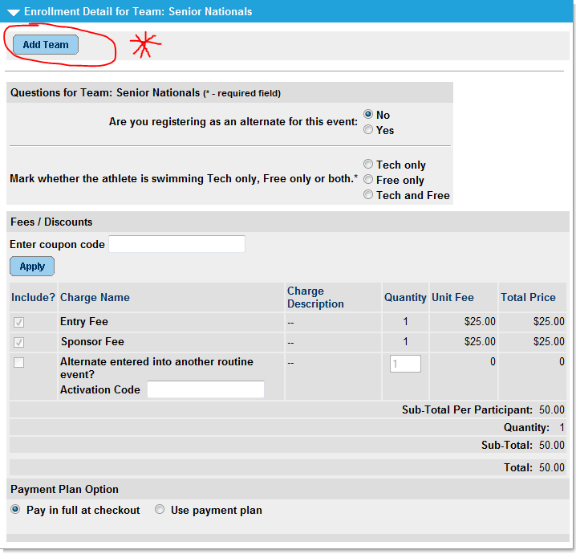
    - Assign a Team Name: This can be any name you choose, but there can be no duplicates. Please use the club abbreviation as a part of the name. The Maximum Number of Team Members is helpful to ensure you have completely filled your team. Remember to allow for an alternate if you have one. (Example: If you have an alternate for a duet, enter 3 as max.)
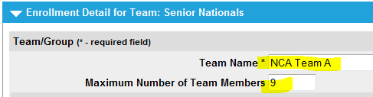
    - Ignore the Security and Invitation fields as these would be used only if each individual registered themselves.
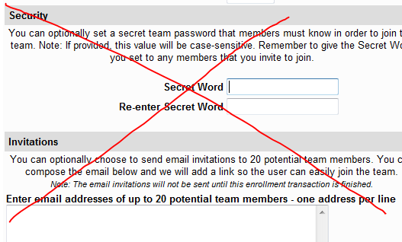
    - Scroll down to answer required questions. It is not necessary to click “Save”, but it will save your answers.
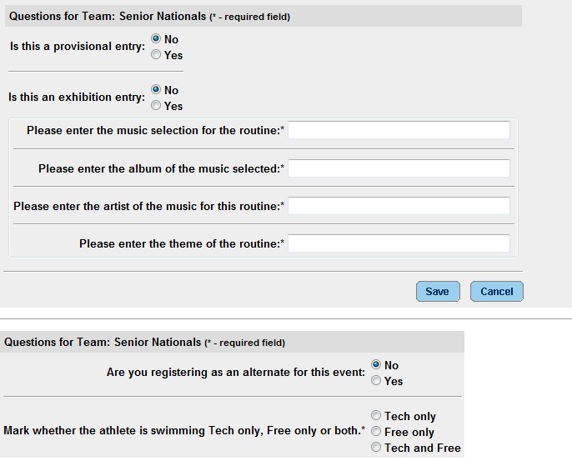
    - Scroll down to the fees. If the athlete is an alternate that is competing in another routine, enter “Yes” in the Activation Code and the system will waive the entry fee.
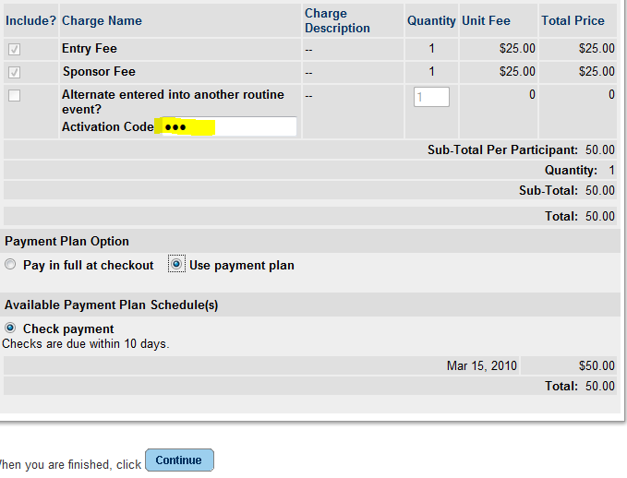
    - Click “Continue”
    - To add another athlete to the same event click “Add Another One”.
    - Use the dropdown arrow to choose the athlete (participant) and click “Continue”.
    - Use the dropdown arrow to choose the same team, or click “Add Team” to create your next team.
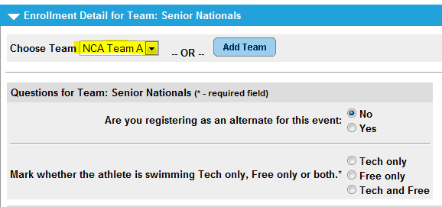
  - To purchase extra items (Credentials, tickets, programs, etc.)
    - Click on the Extra item link.
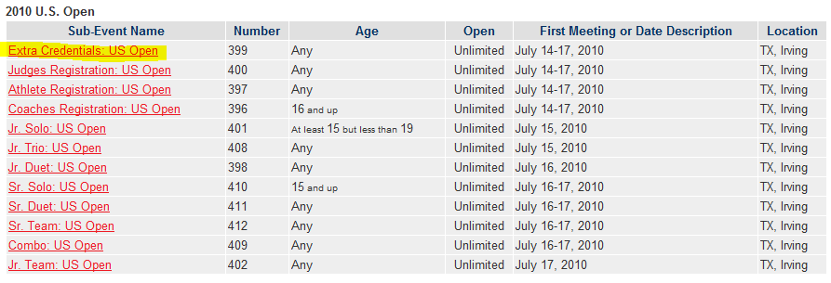
    - Click “Add to my Cart”
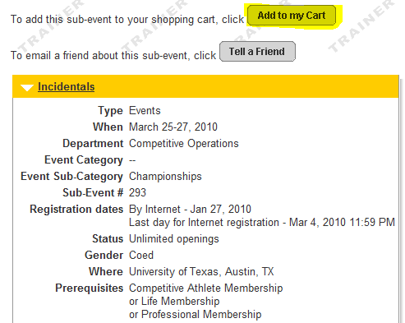
    - Use the drop-down arrow to choose a participant. DO NOT choose the club or an un-registered member. Due to the pre-requisites set on this event, you must choose either a current Life, Professional or Competitive member.
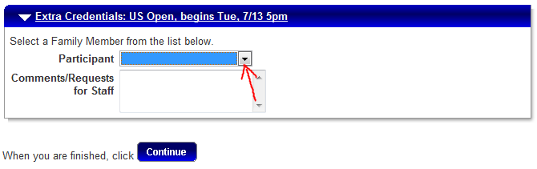
    - Click Continue.
    - Use the checkboxes to select the credentials that you need and enter the quantity if you need more than one.
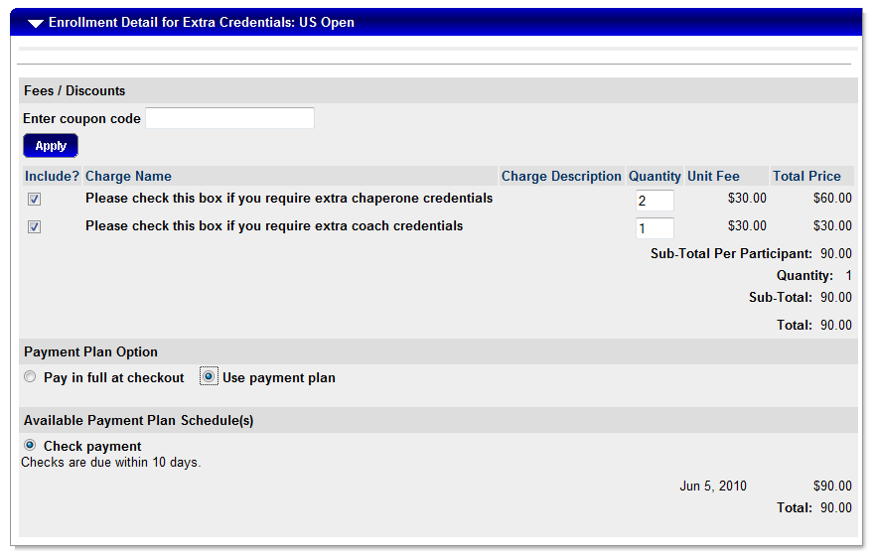
- Click Continue.
- Review your shopping cart carefully to make sure that all entries are correct.
- Click ”Continue” to proceed to checkout.
- Verify that the total charges are correct and click the checkbox to acknowledge the wavier. (You must scroll within the text box for the checkbox to become active.)
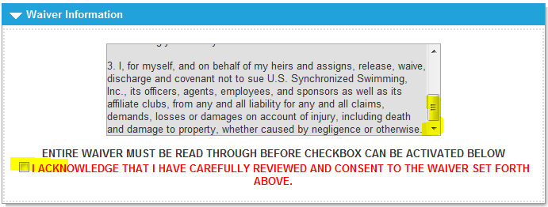
- Click the checkbox to acknowledge that you are over 13, and click “Continue” to complete the process.
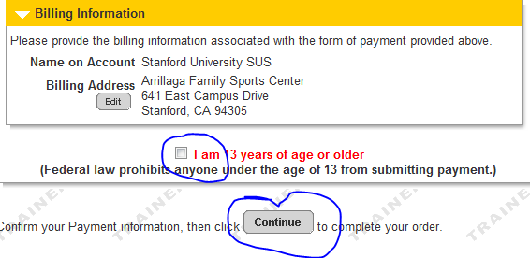
A few items of note:
- Please do not wait for the last day of registration to begin. If you run into technical issues, this may cause you to miss the deadline.
- Please make sure that all your athletes are visible to you upon start of registration. If someone is missing, then please call either Elizabeth or Jennifer at the office to have the athlete’s record located and made visible. This will the registration process go smoother for the user.
- All athletes must be registered into “Athlete Registration”. This is necessary for the scoring program, and collection of the sponsor fees.
- All coaches must register for proper credentialing.
- The system will be checking for correct ages and current memberships. If the athlete’s file has incorrect information (such as birth date) or has been duplicated, you may get an error. Each member needs accurate information in their account for proper enrollment in events.
- If you want to register your team in stages, use the payment plan even if you plan to pay by credit card. For example; you could register all of your solo and duets on Monday, team on Tuesday, and finish with the combo on Wednesday. Then when all entries are complete, you would then click “Pay on Account” to finalize payment.
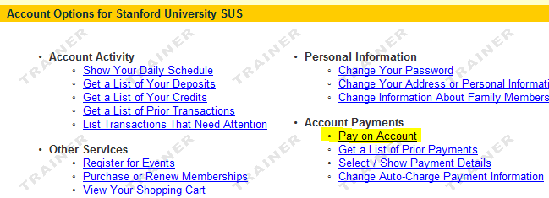
If you have any technical difficulties or questions, please email or call Jennifer at 317-237-5700 x5708 or jennifer@usasynchro.org.

FORM E: HOUSING/TRANSPORTATION

Club/Official Name Club Code
Coach Name_______________________________________ Country __________________________
Email _____________________________________________

Arriving: Air Auto Other
Date Time
Flight Airline

Departure Date Time

Hotel/Lodging Phone
No. Of Athletes
No. Of Coaches/Officials
Names of Coaches attending:
- _______________________________
- _______________________________
- _______________________________
- _______________________________
- _______________________________
(all coaches attending must be on the 100% Complied Coaches Certification List)
Please list three on-site emergency contacts and cell numbers for your club (they may be coaches, officials or parents).
1. _______________________________________________________________
2. _______________________________________________________________
3. _______________________________________________________________
Send to Meet Manager:
Beth Evans
9971 Elmada Lane
Dallas, TX 75220
bethevansdallas@aol.com
FORM H: FOREIGN ENTRY FORM - JUNIOR
Must be completed by all Foreign Federations. Written approval from your Federation MUST accompany this entry. Please contact USA Synchro immediately if you need VISA support.

NAME OF TEAM/FEDERATION

NAME OF HEAD COACH/OFFICIAL

ADDRESS
ADDRESS
PHONE - HOME: WORK:
FAX: EMAIL:

Please complete one form each for Junior, Senior or Combination Routine entries.
.
Select one: National Team Entry Club Entry

Event |  | Names | Date of Birth | Music Theme
SOLO | NAME | 1.
 |  | 2.
 |  | 3.
DUET | NAMES | 1.
 |  | 2.
 | RESERVE
 | NAMES | 1.
 |  | 2.
 | RESERVE
 | NAMES | 1.
 |  | 2.
 | RESERVE
TRIO | NAME | 1.
 |  | 2.
 |  | 3.
 | RESERVE
TEAM | NAMES | 1.
/COMBO |  | 2.
 |  | 3.
 |  | 4.
 |  | 5.
 |  | 6.
 |  | 7.
 |  | 8.
 |  | 9.
 |  | 10.
 | COMBO RESERVES | 1.
 |  | 2.

Name of official: Rating Level:

Name of official: Rating Level:

SPONSOR FEE: # Of Competitors entered (incl. reserves/alternates)_____ x $25 Total Sponsor Fee = $ _____
Make check payable to: USA Synchro (fee will be transferred to the local sponsor)
Mail to: Jennifer Hawkins, USA Synchro, 132 E. Washington Street, Suite 820, Indianapolis, IN 46204, USA
NOTICE: See Events section for complete details. Please also complete Form E Housing/Transportation.
FORM H: FOREIGN ENTRY FORM - SENIOR
Must be completed by all Foreign Federations. Written approval from your Federation MUST accompany this entry. Please contact USA Synchro immediately if you need VISA support.

NAME OF TEAM/FEDERATION

NAME OF HEAD COACH/OFFICIAL

ADDRESS
ADDRESS
PHONE - HOME: WORK:
FAX: EMAIL:
Please complete one form each for Junior, Senior or Combination Routine entries.
Select one: National Team Entry Club Entry
Event |  | Names | Date of Birth | Music Theme
SOLO | NAME | 1.
 |  | 2.
DUET | NAMES | 1.
 |  | 2.
 | RESERVE
 | NAMES | 1.
 |  | 2.
 | RESERVE
TEAM | NAMES | 1.
/COMBO |  | 2.
 |  | 3.
 |  | 4.
 |  | 5.
 |  | 6.
 |  | 7.
 |  | 8.
 |  | 9.
 |  | 10.
 | COMBO RESERVES | 1.
 |  | 2.

Name of official: Rating Level:

Name of official: Rating Level:

SPONSOR FEE: # Of Competitors entered (incl. reserves/alternates)_____ x $25 Total Sponsor Fee = $ _____
Make check payable to: USA Synchro (fee will be transferred to the local sponsor)
Mail to: Jennifer Hawkins, USA Synchro, 132 E. Washington Street, Suite 820, Indianapolis, IN 46204, USA
NOTICE: See Events section for complete details. Please also complete Form E Housing/Transportation.

