

2010 U.S. JUNIOR
SYNCHRONIZED SWIMMING
CHAMPIONSHIPS
March 25th-27th, Austin, TX

OFFICIAL CHAMPIONSHIP ANNOUNCEMENT

CO-MEET MANAGERS

Cheryl Cook
Head Coach
Austin Angelfish
6001 Mountain Villa Dr.
Austin, TX 78731
(512) 567-1943
synchrocc@aol.com
Ann Nellis
Assistant Aquatics Director
University of Texas at Austin
Lee and Joe Jamail Swim Center
(512) 471-7703
ann.nellis@austin.utexas.edu
www.tsc.utexas.edu

FACILITY Lee and Joe Jamail Texas Swim Center
The University of Texas at Austin
1900 Robert Dedman Drive
Austin, 78712-0363
RULES TO GOVERN The 2010 Official USA Synchro Rulebook shall govern the Championships.
SPONSORED BY Austin Angelfish and The University of Texas at Austin
ENTRIES
Appendix A Register online at www.usasynchro.org – (Qualifying documents for all routines MUST be submitted to Dave Olson by March 4, 2010. If qualifying documents are not submitted, your club/routines will not be entered.)
Appendix B Register online at www.usasynchro.org – Entry Fee Summary
Appendix C Register online at www.usasynchro.org – Host Fee Summary
Appendix D Purchase online at www.usasynchro.org – Programs & Spectator Tickets
FORM E Transportation and Housing Information
Appendix F Register online at www.usasynchro.org - Officials Availability
FORM G Music Selection
FORM H Register online at www.usasynchro.org - 2010 Junior Team Trials Phase 1
DEADLINES
PROGRAM PICTURES
Participating clubs are invited to send digital solo, duet, trio and team photos for the program. Cost per photo is $20 if received by February 22 and $25 per photo if received by the latest deadline March 04, 2010.
ENTRY Entries must be completed by March 4, 2010 12:00 PST, and forms must be postmarked no later than March 04, 2010. Use Postal Form #3817 to verify mailing date. (If a qualifying event is held after the entry deadline for this competition, a provisional entry must be submitted according to the above deadline. Within 72 hours of the completion of the qualifying competition, the proof of qualification must be submitted by phone and in writing to the Meet Manager
SEND FORMS E & G and SCOREBOARD CHEERS TO: Ann Nellis
Univ. of Texas- Texas Swim Center
1 University Station D4000
Austin, TX 78712-0363
ann.nellis@austin.utexas.edu
SEND QUALIFYING DOCUMENTS TO: Dave Olson
638 Island Pointe Lane
Moneta, VA 24121
dave_olson@urscorp.com
REGISTRATION Wednesday, March 24th 4-8pm Lee and Joe Jamail Texas Swim Center
Thursday, March 25th 7-11am Lee and Joe Jamail Texas Swim Center

WELCOME RECEPTION & COACHES/OFFICIALS MEETING
Wednesday, March 24th at the Lee and Joe Jamail Texas Swim Center. All officials, coaches, sponsors and alumni are invited to a reception Wednesday evening March 24th, 2010 from 6:30 to 8:00. The meeting will begin at approximately 7:15pm.
POOL SPECS Competition Pool
Length: Competitive area is 25 meters centered between two bulkheads in a 50 meter pool, leaving five 25 yard lanes on either side of the bulkheads for lap swimming.
Width: 25 yards
Depth: 9 feet
Lane Markings: 8 lanes
Deck to Water:
at both bulkhead ends: 16 inches
at sides: even with pool deck
Seating Capacity: Arm chair seating for 1812 spectators
Bleacher seating on left and end of the pool for about 100-150 athletes
Required Entry: Enter from a carpeted bulkhead 7 ft. wide
Practice Pool
Width: 25 yards x 25 yards
Depth: 18 feet
Lane Markings: 4 lanes
Deck to Water: even with pool deck
EVENTS
Figures JUNIOR COMPULSORY
313 Kip Split Closing 180° 2.5
112f Ibis Continuous Spin (720°) 2.8
The remaining two figures will be drawn from the Junior Selection Groups on Monday, March 22nd at 10:00am CST by the USA Synchro VP-Competitive Operations and posted to the USA Synchro website at 10:15am CST. An email will be sent to all technical members of USA Synchro at the same time.
Routines Routine competition in Solo, Duet, and Team
Qualifying Score: Solo: 78.000
Duet: 77.000
Team: 75.000
Combo: no qualifying score required
Note that trios have been eliminated from the US Junior Championship. The Combination event has been added to this meet.
FEE INFORMATION
- Entry Fee $25 per competitor per routine, including alternates. If paying by check, make check payable to USA Synchro. Note: Any swimmer who is listed as an alternate for a routine and who is not swimming any other routine event shall pay the entry fee (2009-2010 Rulebook, Appendix C).
- Sponsor Fee $25 per competitor, including Team Trials only competitors. If paying by check, make check payable to USA Synchro.
- Program Pictures $20 per picture if received by February 22, 2010. $25 per picture if received by the latest deadline of March 4, 2010. If paying by check, make check payable to USA Synchro.
- Personal Greetings $75 Full page, $50 half page, $25 quarter page, $10 per message. The deadline is March 4, 2010. If paying by check, make check payable to USA Synchro.
- Scoreboard Cheers $10 per message. The deadline is March 4, If paying by check, make check payable to USA Synchro.
- Credentials Extra chaperone credentials may be purchased for $10. If paying by check, make check payable to USA Synchro.
- Program $5 per Championship Program ordered in advance, otherwise $10 at the event. If paying by check, make check payable to USA Synchro.
- Tickets Saturday finals spectator tickets can be ordered in advance. Adult tickets $10, Seniors (65+) and Youth (6-12) $5. If paying by check, make check payable to USA Synchro.
- Trials Entry Fee $35 per eligible athlete. If paying by check, make check payable to USA Synchro.

OFFICIALS Register online by March 4, 2010.

SCORING We intend to use new scoring at this meet with three component scores.

HOST HOTELS AT&T Executive Education, Conference Center & Hotel
1900 University Avenue
Austin, TX 78705
Phone: 512-404-1900
Fax: 512-404-1800
Rates: $139
Rooms will be released March 2, 2010
(Please note that the AT&T Center is walking distance from the pool and to many nearby restaurants, so you do not need to rent a car)
Sheraton (note: the pre-selected judges will be housed here)
701 East 11th St
Austin, TX 78701
Phone: 512-478-1111
Rates: $149
Rooms will be released February 23, 2010
Other housing options are listed on the meet website at www.usasynchro.org
AIRPORT Austin-Bergstrom International Airport is located approximately 13 miles from the Texas Swim Center.
To help our members, we have an agreement with United Airlines. To receive a discount off the lowest available fare, call United at 800-841-0460 and tell them you're with "U.S. Synchronized Swimming" and use code 565EG.
DIRECTIONS From Austin-Bergstrom Airport to the Pool. The airport is located about 13 miles southeast of the university. Take Highway 71 West toward Austin. Exit I-35 North. Exit MARTIN LUTHER KING JR BLVD (MLK). Turn LEFT (west) onto MLK. Take MLK to TRINITY (the second stop light). Turn RIGHT onto TRINITY. Athlete drop off is in the first driveway on the right (the TSC/School of Social Work circle driveway).
GROUND TRANS. All major rental car companies available at the airport.
Super Shuttle 800-258-3826 (10% discount if you use the Group Discount Code D3N9G) 800-258-3826 http://www.supershuttle.com/default.aspx?GC=D3N9G
PARKING Parking is across MLK Blvd. from the Texas Swim Center in the Trinity Parking Garage. Swipe cards are available for purchase during registration for $32 for 4 days with In-Out privileges or $10 per day
PRACTICE Practice Pool time is available Wednesday March 24, 2010 and throughout the week at the Lee and Joe Jamail Swim Center. Contact Ann at ann.nellis@austin.utexas.edu for space and fees.

VENUE RULES
- Obey lifeguards at all times.
- In case of an accident, a lifeguard must be notified immediately and must complete a report. The meet manager must also be notified.
      - Food is permitted on the pool deck. Each Club is allowed a maximum of two ice chests in the athlete seating area only. No ice chests are allowed up in the spectator stands or in the balcony area.
      - Glass of any kind is not allowed anywhere in the facility or on the pool deck. Plastic water bottles are allowed.
      - No balloons are allowed in the facility.
      - No cooking or tables will be allowed in the facility.
      - The hospitality area is for officials, coaches, alumni and sponsors only.
      - Locker rooms: Limited lockers are available for day use only, you may bring a lock.
GELLING Gelling is only allowed in the designated gelling station room located outside the pool deck, near the diving well. Those gelling outside the designated areas will incur a $100 fine subject to immediate payment to The University of Texas. No Exceptions. Please clean the area when done. On Saturday only, you may de-gel outside with a provided hot water hose, before entering the shower in the locker room. Anyone found de-gelling in the shower or locker room will be immediately fined $100 payable to the The University of Texas.
CREDENTIALS All participants, officials and volunteers will receive credentials. Each club will receive 2 coach and 1 chaperone credential per 10 credentialed athletes. Chaperone credentials do not allow deck access. Extra chaperone and coach credentials can be purchased for $10 each.
Coaches are reminded that they need to carry their USA Synchro proof of certification to be allowed on deck.
Restricted access to the facility will be strictly enforced. Please wear your credential at all times. There is a $15 replacement charge for lost credentials. Make check payable to The University of Texas.
SOUND SYSTEM A Clark Synthesis sound system with CD player will be used.
OFFICIALS AND COACHES HOSPITALITY
Food will be available in the hospitality room throughout the competition for Officials and Coaches. We hope you enjoy “A Taste of Texas”! A schedule will be posted and provided with the Registration Packets.
PROGRAM Championship Programs may be purchased in advance for $5, or they can be purchased for $10 at the event. Be sure to take home copies of the Championship Program for family and club members who could not attend!
PROGRAM PICTURES Save photos as a JPEG (.jpg) digital file. Set JPEG compression for high quality. If prepared correctly the digital JPEG attachment should be between 250K and 1MB. Send photos as an attachment to an e-mail. In the e-mail subject line indicate the club name. In the body of the e-mail include the complete name of club, city, state, description of photo, and name of the swimmers. (DO NOT send a word text document.) Name your attached photo file a name that describes your team photo (i.e. SST_trio.jpg) Send one photo and caption per e-mail (i.e. 4 photos = 4 e-mail messages.) E-mail photos to: ann.nellis@austin.utexas.edu.
PERSONAL GREETINGS
Family and Friends can submit personal greetings and pictures to be included in the championship program. Personal messages of good luck and a job well done can be submitted along with or without a photo. These photos and messages will be placed randomly in the program and will not be included in the team area of the program.
OPTIONS
Full-page 5”x7” picture and 50 words or less $75
Half-page 6”x4” picture and 25 words or less $50
¼ page 3½”x5” picture and 15 words or less $25
Greetings only no picture (25 words or less) $10

PHOTOS AND GREETINGS
Photos & Greeting to be received by e-mail by March 4, 2010.
Photos to be sent as a high resolution JPEG file (.jpg). Greetings as an e-mail message. (DO NOT send a word file attachment.)
SCOREBOARD Wish your routine competitors good luck in lights on our giant 25’ scoreboard. Your wishes will flash your message repeatedly during warm-ups for routine events. You can let your swimmer know that you’re thinking of them from far away. Greetings can be pre-purchased or purchased at the meet. See enclosed flyer for instructions.
CLUB BANNERS Club banners will be collected at the registration table for staff to hang.
FOOD SERVICES A concession stand with healthy and reasonably priced food options is located in the balcony lobby of the aquatic center. Visit the meet website, www.usasynchro.org for a copy of the menu. Outside food for the athletes only, is allowed in the building. Coolers are only allowed on deck behind the athlete seating area. Outside food is not allowed in the balcony area. NO cooking or portable tables in the building. No glass containers permitted on the pool deck.
SPECTATOR TICKETS Tickets for Saturday’s finals can be ordered in advance the USA Synchro website. $10 for general admission, $5 seniors (65+) and youth (6-12), 5 and under free. Life members get free admission into all national events and register online.
PHOTOGRAPHER The official photographer for USA Synchro is MIGZ Photography, from whom you can order photographs onsite. Cameras with detachable lenses will not be allowed in the competition venue.

PHOTO/VIDEO REGULATIONS
Any photographs, videotape or other audio and/or visual recordings of the event created by a spectator may be used solely for such spectator's personal non-commercial use, and may not be broadcast, published or disseminated, or used for any commercial purposes, without the prior written consent of USA Synchro.
MEDIA SERVICES To assist the USA Synchro Media Relations Director at the event, please bring a phone/fax list of your local media outlets. You can acquire this list from a local university athletic department Sports Information Office, university Media Relations, or your local government public relations office.
2010 JUNIOR TEAM TRIALS – Phase 1
Eligible athletes must compete in the Figure competition at the 2010 U.S. Junior Championship. Athletes who have a Solo and Duet routine qualifying score and who do not intend to compete at the U.S. Junior Championship, but are qualified to participate in the 2010 Junior Team Selection Process may enter the Figure competition at the 2010 U.S. Junior Championship. Athletes who meet this criteria and want to compete in the Trials must pay, in addition to the Trials entry fee, the Sponsor Fee. For the Junior Team Trials Selection Procedures, please see the 2010 Official USA Synchro Rulebook Appendix E or USA Synchro website.
JUNIOR CLINIC Sunday, March 28th Tentative Esynchro clinic for Junior athletes who register. Registration information to be posted on www.usasynchro.org.
SCOREBOARD CHEERS ORDER FORM

Cheer on your favorite synchronized swimmer(s) by ordering messages to be displayed in lights on the giant 25’ scoreboard during routine warm-ups. The cost is $10 per message. The messages will be displayed multiple times during the selected warm-up session. Please purchase online and email, mail or fax orders To: Ann Nellis, Univ. of Texas- Texas Swim Center, 1 University Station D4000, Austin, TX 78712-0363
Orders can be submitted at the pool at least two hours prior to the beginning of warm-ups.

Your Name _____________________________Club_________________ Phone___________________

Swimmer(s) Names: ___________________________________________________________________

Total Amount Paid: ______________

Warm-Up Session Selection:
______Solo ______ Duet ______Trio ______Team

______Preliminary Events or ______Finals

Choose from either the two-line or four-line version below. One letter per box with an empty box between words. Scoreboard operator will center each line of text

TWO LINE



OR

FOUR LINE



Complete one form per event.
TENTATIVE SCHEDULE
Please consult the FINAL SCHEDULE distributed at Registration for updates or adjustments.
Note that warmups may be split into first and second half, depending on size
Wednesday, March 24, 2010
daytime | Fee-based Practice Only
6:30 pm – 8:00 pm | Welcome Reception / Coaches & Officials Meeting
Thursday, March 25, 2010
7:00 am – 7:30 am | Lap Swimming
7:30 am – 8:00 am | Figure Warm-up
8:05 am – 3:00 pm | Figure Competition-Junior Team Trials Phase 1
3:30 pm – 4:30 pm | Combo Practice – with music
4:30 pm – 7:30 pm | Team Practice – with music
Friday, March 26, 2010
7:30 am – 8:00 am | Lap Swim
8:00 am - 8:20 am | Duet Warm-up
8:25 am – 11:55 am | Duet Semi-Final Competition
11:55 am – 12:25 pm | Lunch Break
12:25 pm – 12:45 pm | Solo Warm-up
12:50 pm – 3:35 pm | Solo Semi-Final Competition
4:30 pm – 5:00 pm | Team Warm-up
5:00 pm - 7:00 pm | Team Semi-Final Competition
Saturday, March 27, 2010 | *Note – During Finals, the diving well will only be used for lap swimming for warm-up for the next event. The lap lanes on either side of the competition pool are closed except to the prior routine cooling down before their scores are read.
8:00 am – 8:30 am | Lap Swim
8:30 am – 9:00 am | Combo Warm-up (15 min each half )
9:05 am – 10:15 am | Combo Semi-Final Competition
10:20 am – 11:00 am | Duet & Solo Warm-up (20 min each)
11:05 am – 11:55 am | Duet Final Competition
12:00 am – 12:45 pm | Solo Final Competition
12:55 pm – 1:25 pm | Team Final Warm-up (15 min each pre-4, 5-8)
1:30 pm – 2:30 pm | Team Final Competition
2:35pm – 3:05 pm | Combo Warm-up (15 min each half)
3:10 pm – 4:15 pm | Combo Final Competition
4:30 pm – 5:00 pm | Parade of Athletes and United States Synchronized Swimming National Team Exhibition
5:00 pm | Awards
5:00 – 6:00 pm | “Give Synchro a Try” A free, one hour session for Austin area 8- 12 yr olds, after the National Team Exhibition – hosted by the Austin Angelfish swimmers and coaches.
Sunday, March 28, 2010
9:00 am – 1:00 pm | Esynchro clinic for Junior athletes who register


Appendix A & B: Club Entry Form & Entry Fee Summary
- To register online login to your account from the homepage of the USA Synchro website, by clicking on “Members Log-In”.
- Login to your account. 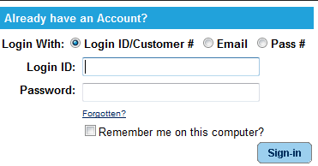
- Click on “Register for Events” under the “Other Services” section.
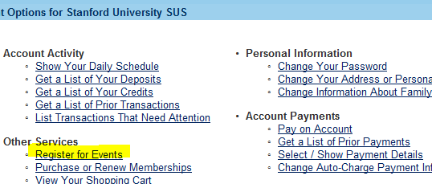
- Click on the link for the 2010 U.S. Junior National Championships.
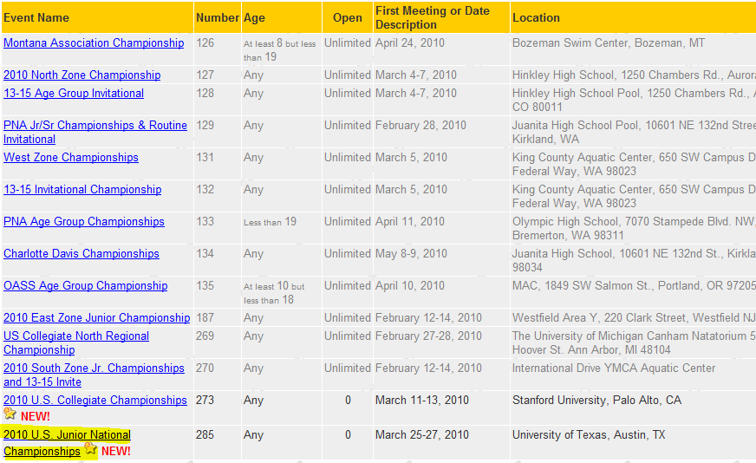
- Click on the event for which you are registering your athlete.
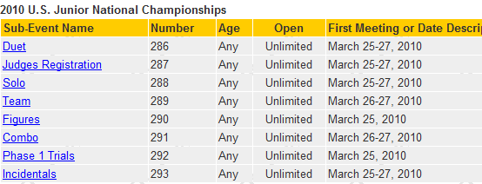
  - To Register for individual events such as solos and figures events:
    - Click “Add to My Cart”
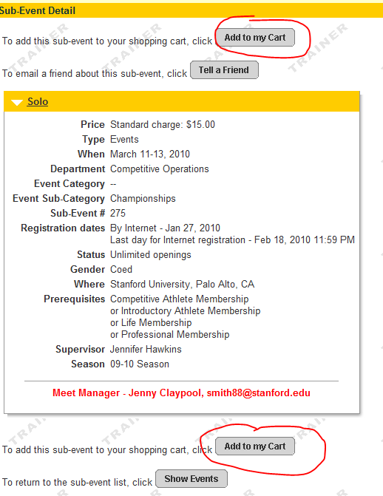
    - Use the drop-down arrow to choose the athlete (participant) entering the event.
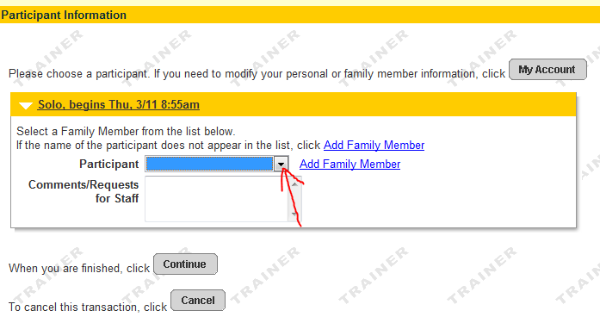
    - A new payment option is available for clubs that need to pay by check. If you are choosing to mail in a check; you will need to choose the payment plan on every athlete; every event that you enroll, for the system to defer all charges. If you miss even one, you will be asked to pay by credit card upon check out.
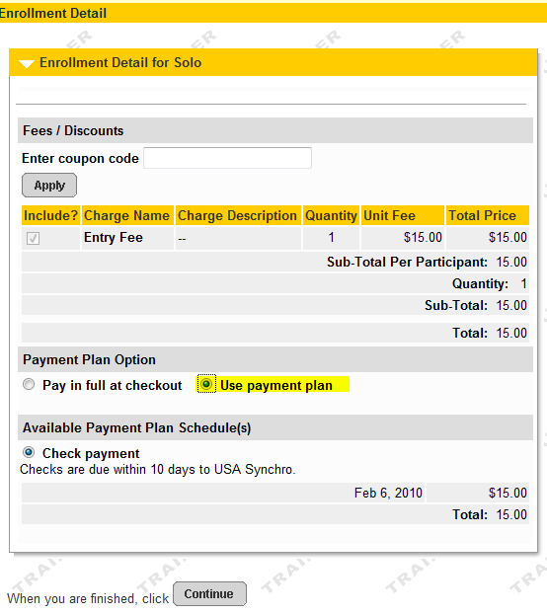
    - Click continue and your shopping cart will reflect a summary of your transaction.
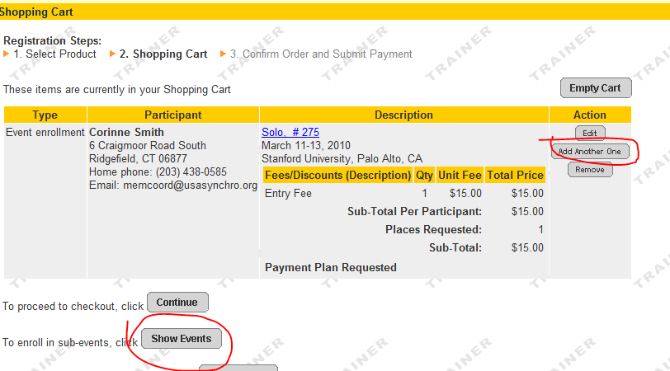
    - If you need to add another althete to the same event, click “Add Another One”. If you are ready to choose a new event, click “Show Events”.
  - To register for team events:
    - Click “Add to My Cart”
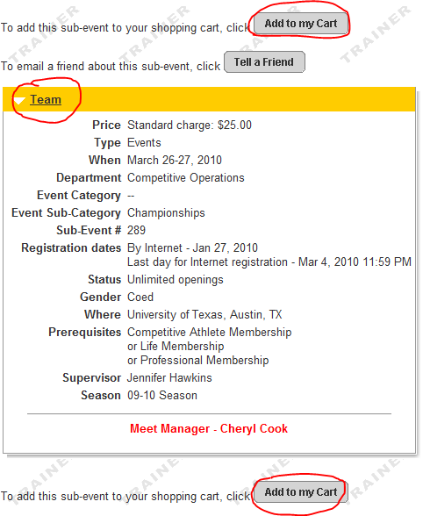
    - Use the drop-down arrow to choose the athlete (participant) entering the event and click “Continue”.
    - Click “Add Team”
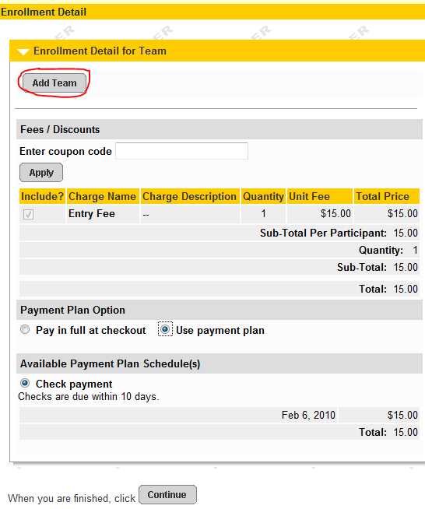
    - Assign a Team Name: This can be any name you choose, but there can be no duplicates. For reporting purposes, it is helpful to have the club abbreviation as a part of the name. The Maximum Number of Team Members is not required, but if you only put 2 for a Duet (for example) you will not be able to register an alternate.
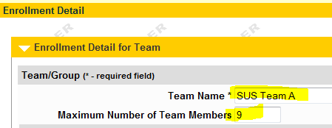
    - Please ignore the Security and Invitation fields. This would be used only if each individual registered themselves.
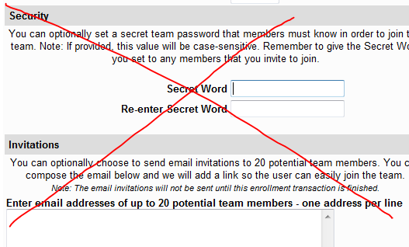
    - Scroll down to answer the following questions. The default has been set to “no”. There is no value in using the “Save” button; instead scroll on down and click “Continue”.
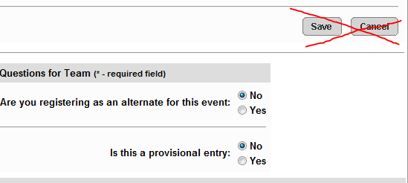
    - To add another athlete to the same event click “Add Another One”.
    - Use the dropdown arrow to choose the athlete (participant) and click “Continue”.
    - Use the dropdown arrow to choose the same team, or click “Add Team” to create your next team.
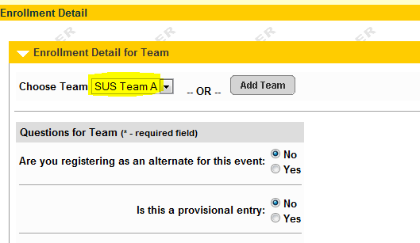
- Review your shopping cart carefully to make sure that all entries are correct.
- Click”Continue” to proceed to checkout.
- Verify that the total charges are correct and click the checkbox to acknowledge the wavier. (You must scroll within the text box for the checkbox to become active.)
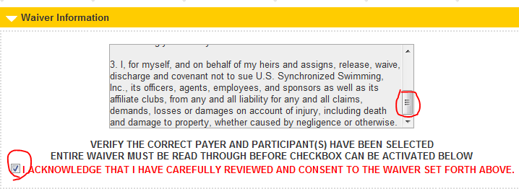
- Click the checkbox to acknowledge that you are over 13, and click “Continue” to complete the process.
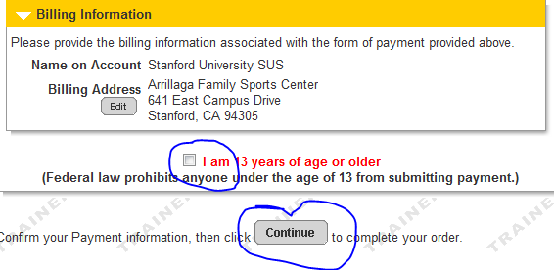

A few items of note:
- The system will be checking for correct ages and current memberships. If the athlete’s file has incorrect information (such as birthdate) or has been duplicated, you may get an error. Each member needs accurate information in their account for proper enrollment in events.
- If you want to register your team in stages, use the payment plan even if you plan to pay by credit card. For example; you could register all of your soloists and duets on Monday, team and trio on Tuesday, and finish with the technical events on Wednesday. Then when all entries are complete, you would then click “Pay on Account” to finalize payment.
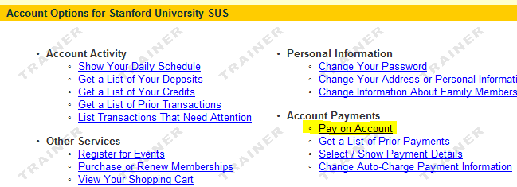
If you have any technical difficulties or questions, please email or call Jennifer at 317-237-5700 x5708 or jennifer@usasynchro.org.

FORM C & D: HOST FEE SUMMARY, PROGRAM & SPECTATOR TICKETS

To be completed online by March 4, 2010

- To register online login to your account from the homepage of the USA Synchro website, by clicking on “Members Log-In”.
- Login to your account.
- Click on “Register for Events” under the “Other Services” section.
- Click on the link for the 2010 U.S. Junior National Championships.
- Click on the Incidentals link.
- Click “Add to my Cart”
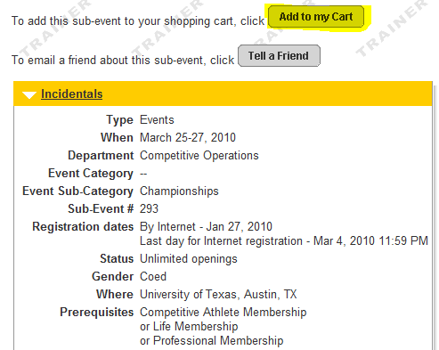
- Use the drop-down arrow to choose a participant. DO NOT choose the club or an un-registered member. Due to the pre-requisites set on this event, you must choose either a current Life, Professional or Competitive member.
- Click Continue.
- Use the checkboxes to select optional charges such as Programs, Pictures, Greetings, Tickets, etc.
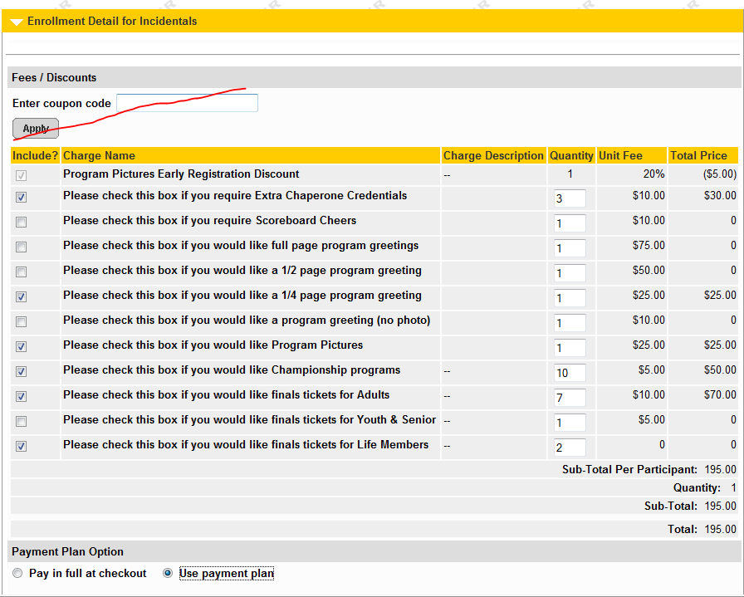
- Click Continue.
- Check your shopping cart to verify all charges.
- Click Continue to proceed to checkout.
If you have any technical difficulties or questions, please email or call Jennifer at 317-237-5700 x5708 or jennifer@usasynchro.org.
FORM E: TRANSPORTATION AND HOUSING INFORMATION

Club/Official Name Club Code

Contact Name __________________________________ Email _________________________

Contact Phone

ENTRY DEADLINE = MARCH 4, 2010

TRANSPORTATION

Arrival Please circle one: Air Auto Other

Date___________________________ Time _____________________________

Airline / Flight Number __________________________

Departure

Date ________________________ Time ________________________________

Airline / Flight Number _________________________

HOTEL/LODGING

Hotel/Lodging _________________________________ Phone____________________

No. of Athletes__________ No. of Coaches/Officials __________

EMERGENCY CONTACT INFORMATION
Please list three on-site emergency contacts for your club (these may be coaches, officials, chaperones or parents).

Name Cell Phone Number

1. _________________________ ____________________________

2. _________________________ ____________________________

3. _________________________ ____________________________

APPENDIX F: OFFICIALS AVAILABILITY

*Officials: Please only register online at www.usasynchro.org for this meet if you are a Level IV Judge or higher.
Register online by March 4, 2010.
- To register online, login to your account from the homepage of the USA Synchro website by clicking on “Members Log-In”.
- Login to your account.
- Click on “Register for Events under “Other Services.
- Click on the link for the 2010 U.S Junior National Championships.
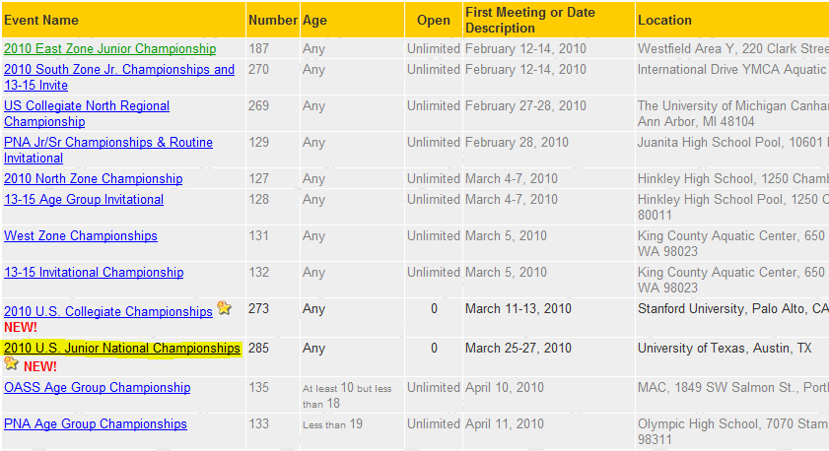
- Click on the link for “Judges Registration”.
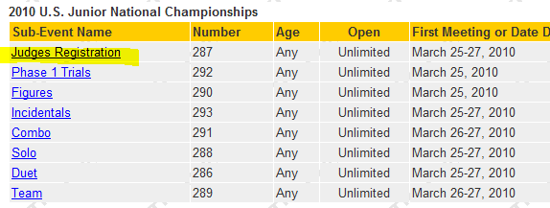
- Click “Add to my Cart”.
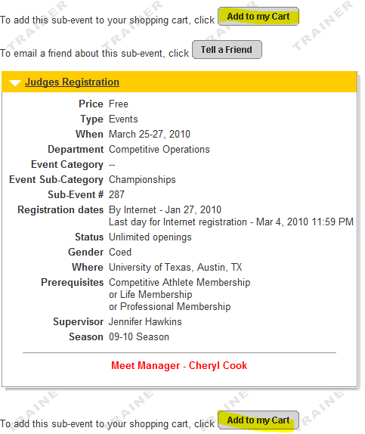
- Click the dropdown arrow to choose the judge (participant) and click “Continue”.
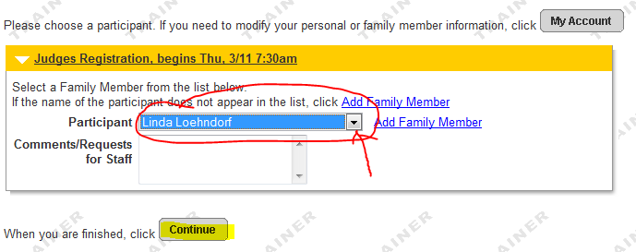
- Answer the questions regarding your travel plans, availability and affiliation; and click “Continue”.
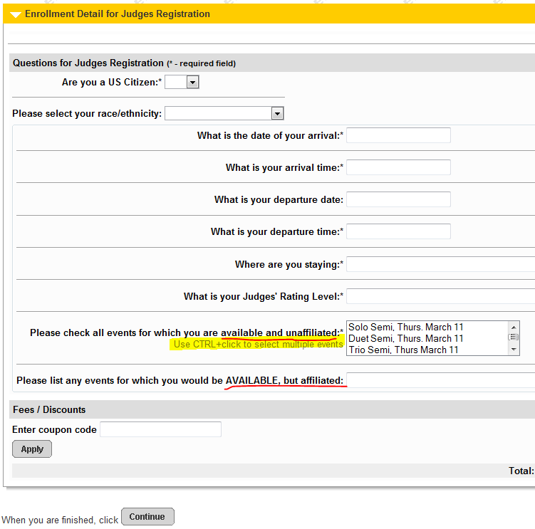
- Verifiy that your answers in the shopping cart are correct. If they are not, you can click “Edit” to make changes; otherwise click “Continue” to checkout.
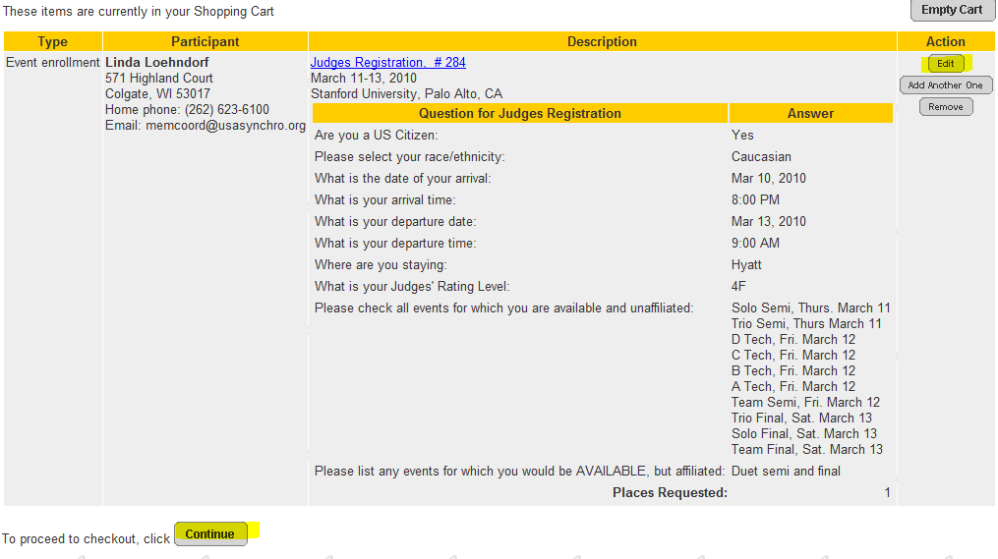
- Click the checkbox to acknowledge the wavier. (You must scroll within the text box for the checkbox to become active.)
- Scroll down to the bottom of the page and click “Continue” to complete your registration.
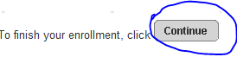
An item of note:
- The system will be checking for current memberships. If your file has incorrect information or has been duplicated, you may get an error. Each member needs accurate information in their account for proper enrollment in events.
If you have any technical difficulties or questions, please email or call Jennifer at 317-237-5700 x5708 or jennifer@usasynchro.org.
FORM G: MUSIC SELECTION

Club/Official Name Club Code

Contact Name __________________________________ Email _________________________

Contact Phone

ENTRY DEADLINE = MARCH 4, 2010

Routine | Routine Theme | Music Selections | Artists | Album Name
Ex: Sally’s Solo | Carmina Burana | Carmina Burana | Orff; Eugene Ormandy | Orff: Carmina Burana
FORM H: 2010 JUNIOR TEAM TRIALS PHASE 1REGISTRATION FORM
Register online at www.usasynchro.org by MARCH 4, 2010
- To register online login to your account from the homepage of the USA Synchro website, by clicking on “Members Log-In”.
- Login to your account.
- Click on “Register for Events” under the “Other Services” section.
- Click on the link for the 2010 U.S. Junior National Championships.
- Click on the Phase 1 Trials.
- Click “Add to My Cart”
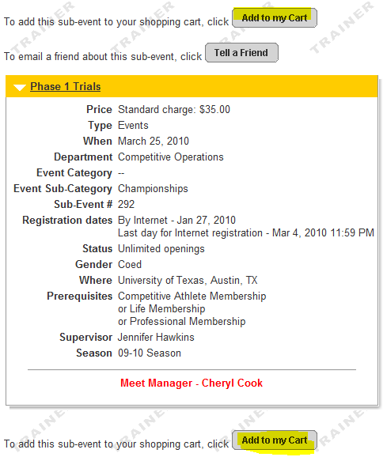
- Use the drop-down arrow to choose the athlete (participant) entering the event.
- Answering “Yes” in the Activation Code will trigger the system (after you click continue) to collect the Sponsor fee if you are entering a trials only athlete. The US Citizen question is a required field.
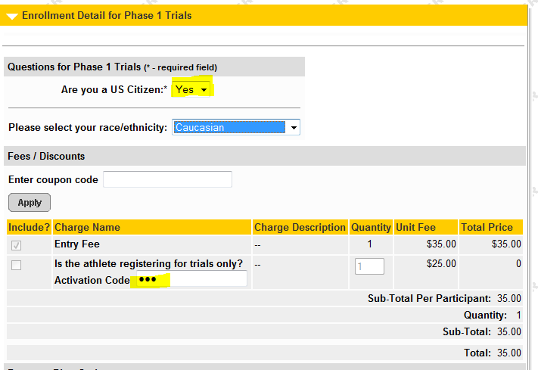
- A new payment option is available for clubs that need to pay by check. If you are choosing to mail in a check; you will need to choose the payment plan on every athlete; every event that you enroll, for the system to defer all charges. If you miss even one, you will be asked to pay by credit card upon check out.
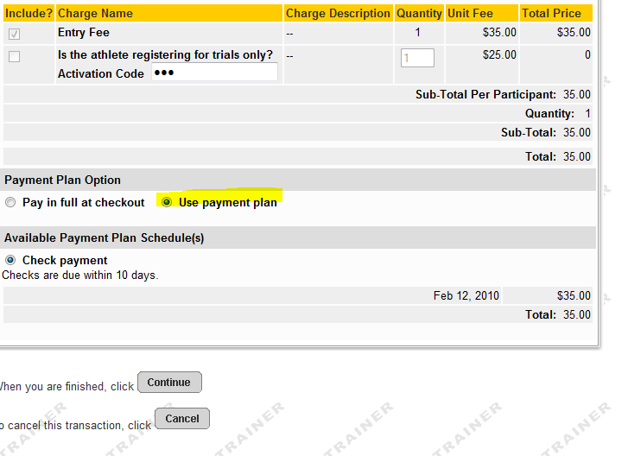
- Click continue and your shopping cart will reflect a summary of your transaction. Make sure all entries are correct and none show incomplete.
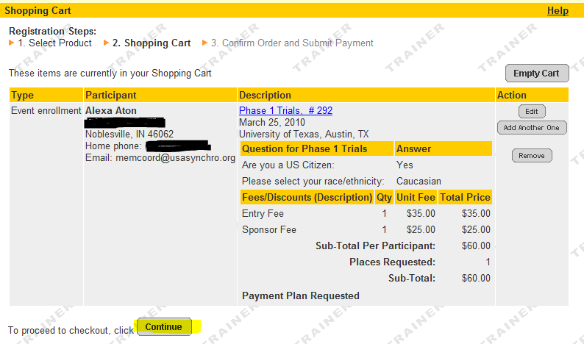
- Click Continue to proceed to checkout.
- Click the checkbox to acknowledge the wavier. (You must scroll within the text box for the checkbox to become active.)
- Scroll down to the bottom of the page and click “Continue” to complete your registration.
An item of note:
- The system will be checking for proper ages and current memberships. If your file has incorrect information or has been duplicated, you may get an error. Each member needs accurate information in their account for proper enrollment in events.
If you have any technical difficulties or questions, please email or call Jennifer at 317-237-5700 x5708 or jennifer@usasynchro.org.

